Problem 2 - Numbers
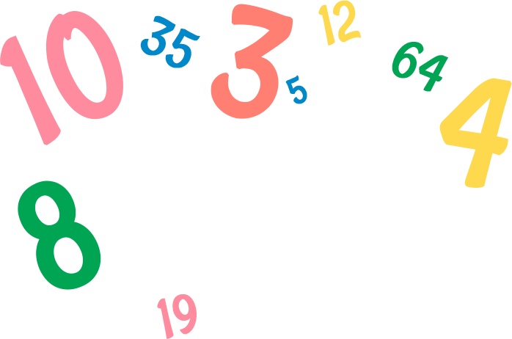
You are given numbers in a sequence on a single line, separated by a space. After that, you will receive commands that modify the sequence differently:
- "Add {value}" - you should add the given value to the end of the sequence.
- "Remove {value}" - you should remove the first occurrence of the given value if there is such.
- "Replace {value} {replacement}" - you should replace the first occurrence of the given value with the replacement if there is such occurrence.
- "Collapse {value}" you must remove each number with a value less than the given one.
When you receive the command "Finish", you should print the modified sequence and end the program.

Input / Constraints
- On the first line, you will receive a sequence with numbers, separated by spaces - integers in the range
[-1000…1000].
- On the following lines, you will receive commands until the "Finish" command is received.
- The commands will always be valid.

Output
- Print a single line the array of numbers separated by a space, with the modified values.

Examples
Input | Output
1 4 5 19  Add 1  Remove 4  Finish | 1 5 19 1
1 20 -1 10  Collapse 8  Finish | 20 10
5 9 70 -56 9 9  Replace 9 10  Remove 9  Finish | 5 10 70 -56 9

JS Examples
The input will be provided as an array of strings.
Input | Output
(["1 4 5 19",  "Add 1",  "Remove 4",  "Finish"]) | 1 5 19 1
(["1 20 -1 10",  "Collapse 8",  "Finish"]) | 20 10
(["5 9 70 -56 9 9",  "Replace 9 10",  "Remove 9",  "Finish"]) | 5 10 70 -56 9

